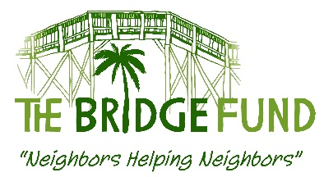

REQUEST FORM FOR BRIDGE FUND ASSISTANCE

Submit to: Beverly Haas, BeverlyVHaasTBF@gmail.com, 617-645-4165
or to Michael Beebe, mbeebe@aol.com, 239-682-3855

Please submit as a Word document. We cannot accept a PDF or photocopy of this form.

Please answer all questions (if not applicable, indicate N/A)

Date:

School Name:

School Contact Name and Position:

Contact Phone #: Contact Email:

A. SUMMARY OF NEED

1) Name of person(s) needing assistance:

2) Specific Need (rent [which month], electric bill, MRI, car repair, education, etc.):

3) How many persons will benefit if this request is approved?

_____ Adults

_____Children (include ages) ___________________

4) Is this a one-time need? Yes ____ No____;

Has the person/family received help from TBF or any other agency or charity, or a referral for case management within the past year?

Yes ____ No____

If Yes, please list the agencies (including The Bridge Fund) and describe assistance:

B. FUNDS REQUESTED

All agencies or possible resources contacted. For agencies or charities, include (i) contact name and (ii) result.

5) a) Amount required to meet the TOTAL need: $ _________________ (a – b = c)

b) Funds to be provided from any other source, including person needing assistance: $________

Include names of individuals or agencies: ______________________________

c) Remaining funds requested from TBF to complete need: $___________________

C. BACKGROUND DESCRIPTION OF NEED
1) Provide a detailed background description of what brought about this immediate need.

2) What are the plans for self-sufficiency in the future?

D. PAYMENT DETAILS

1) Date funds needed: _______________ (can indicate ASAP or deadline date)

2) Please provide complete payment or delivery instructions.

Request for a payment: Include payee information (name, address, phone number) and payment account number. List payment portal website, user name and password if bill/rent is paid online.

Request for a delivery: Provide the recipient’s name, address and phone number.
Name__________________________________
Address ________________________________
Phone number ___________________________
Account number_________________________
Payment portal website_________________, username_____________, password____________

3) In addition, please provide a legible copy of an invoice, lease, bill or other documentation that supports the funds needed.

_______________________________________________________
For Bridge Fund use only.

Request approved: denied: Date: Amount:

